YEAR 7 HUMANITIES ASSESSMENT TASK: Liveability and My Local Area

Systems: For individuals and societies, “systems thinking” provides a powerful tool for understanding both natural and human environments, and the role of individuals within them. Social and natural systems rely on a state of equilibrium and are vulnerable to change from internal and external forces.
Statement of Inquiry: The interaction between human and natural environments contribute to liveability
Assessment Criteria: B: Investigating C: Communicating D: Thinking Critically

Task: To investigate the liveability of my local neighbourhood by collecting and recording geographical data in a PowerPoint Report. To collect your data, you will complete a walking audit of your neighbourhood and record features and facilities, as well as photos of the important features and facilities of your local area.
Academic Honesty: Students are reminded that all work submitted must be their own and each use of words, work or ideas of another person, whether written, oral or visual, (hard copy and /or electronic materials) must be acknowledged in the body of their work and the bibliography.

Due Date:________________________________

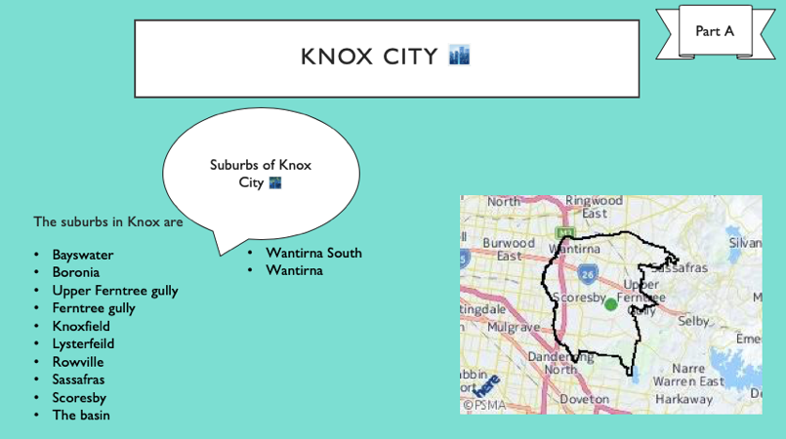
Section A - Location and scale
Time provided: 1-2 periods

SLIDE 1
- Determine which local council (local government) manages your neighbourhood. Use the following link as a resource: http://knowyourcouncil.vic.gov.au/councils
- Name the council and copy and paste the map of the council area.
- Name all of the suburbs located in your local government area
SLIDE 2
You will need a range of maps at different scales to demonstrate where your neighbourhood is.
Map 1: Suburb map – include a map of your suburb, using either of the following sites 2kmfromhome.com or GoogleMaps or VIC NAMES
Map 2: Neighbourhood map (the area of your walking audit)
SLIDE 3
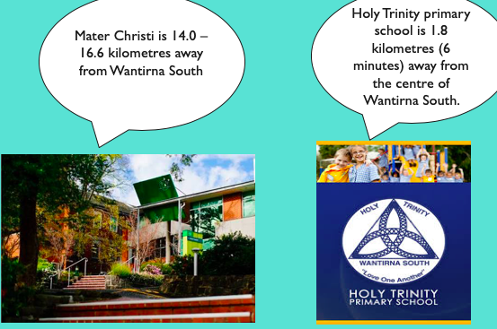
Photos of your street
SLIDE 4
Include the distance and direction of your house from Mater Christi College (e.g. 16km from my home in a Northerly direction).

Section B - An audit of my walk around my neighbourhood
Now it’s time to go on your walk. Take a family member with you or a friend! This is your homework!
Remember to take:
- A printed A4 neighbourhood map (or screenshot)
- The Walking Audit checklist
- Liveability data collection table (your teacher gave you a printed copy)
- a pen/pencil
- A phone or camera to take photographs of positive and negative features that will help you assess the liveability of your local neighbourhood.
This website has many ideas about what to look out for, whilst completing your audit of the street: www.victoriawalks.org.au/Walking_audit/
Time provided: 2 periods
SLIDES 5-10
Summary of walkability: Create one slide for each of the 6 criteria from your audit. Write a short summary of what you found out about each of the criteria below. Include annotated photographs with your summary (see example)
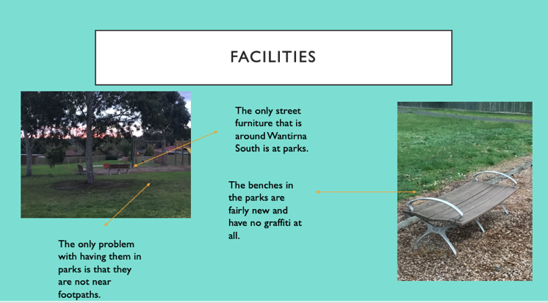

- Footpaths
- Facilities
- Crossing the road
- Traffic
- Safety
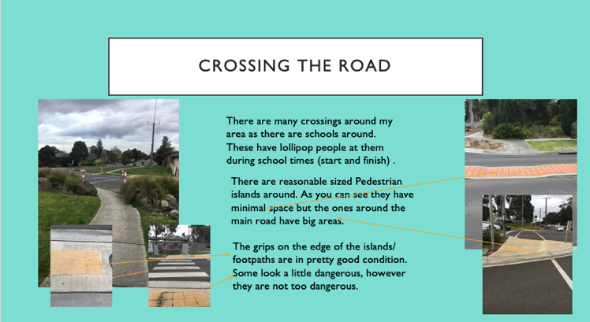
- Aesthetics (looks/surrounds)

Section C - Analysis of my local area
Time provided: 3 periods
SLIDE 11
Using a map of your local area, show the following features:
a. Where you walked; use arrows to indicate direction
b. Your street
c. Features of importance such as parks, shops and crossings; use a key
d. Check that your map includes all BOLTSS
SLIDE 12-13
Provide examples of two Positive features you observed during your neighbourhood walk. On each slide, include a photo showing the feature and a summary of how it contributes and benefits the liveability of your neighbourhood. Examples: green spaces, community spaces, playgrounds, lakes, gardens with flowers etc.
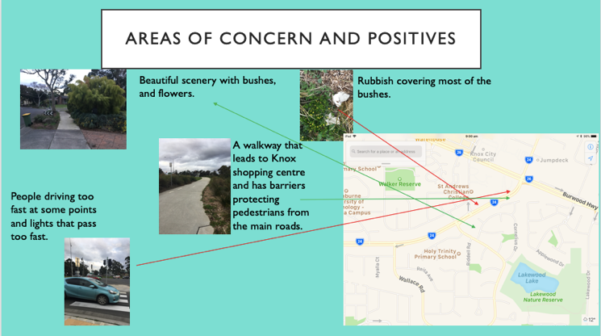
SLIDE 14-15
Provide examples of two Negative features you observed during your neighbourhood walk. On each slide, include a photo showing the feature and a summary of how it decreases the liveability of your neighbourhood. Examples: graffiti, rubbish, damaged fences, damaged paths, ugly features .
SLIDE 16
Concluding paragraph: Write how the liveability of your local area could be improved by referring to your audit and pictures as evidence. Can you suggest some ideas that could be given to your local council that would help to improve the liveability of your local area?
SLIDE 17
Bibliography: Include at least four different references at the end of your report. Don’t forget to use My Bib to set out your resources accurately.
SLIDE 18
Appendix: Photographs/evidence of your completed Walking Audit form

