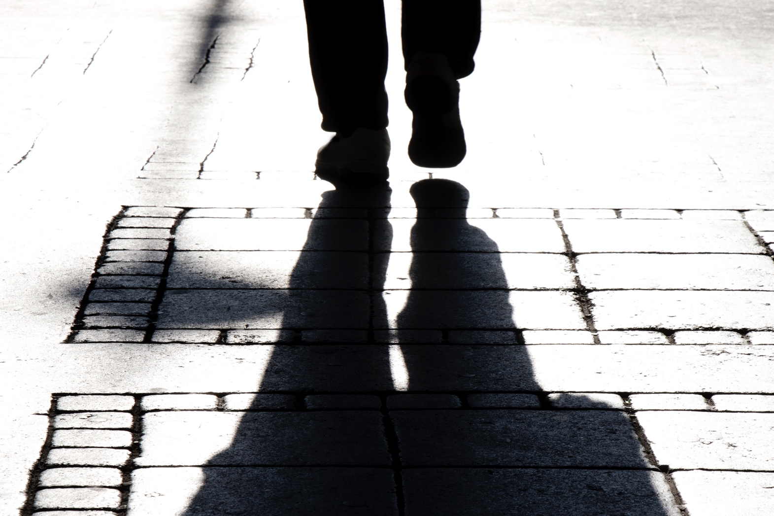
WHAT TO LOOKOUT FOR WHILST ON YOUR NEIGHBOURHOOD
FIELDWORK WALK.

GEOGRAPHY Year 7
1. | Does the footpath go the whole way, on both sides of the street, with no missing sections?  - It‟s not always necessary to have footpaths on both sides of every street, as long as there is a safe and continuous path for people to get to where they want to go.  - Does the footpath suddenly stop? People will need to turn back, find another route, or cross the road, which may be dangerous. These kinds of problems will discourage people from walking in the area.  - What if there is a missing section in the footpath? Small gaps can make a whole area or route difficult for some people (eg. people in wheelchairs or pushing prams).
2. | Are the footpaths non-slip, smooth, even and well maintained?  - Ideally, footpaths should be smooth and even, with no uneven or dangerous footpath surfaces that can cause people to fall and injure themselves.  - Sometimes tree roots can cause the footpath to become uneven, or rubbish or fallen leaves can make the footpath slippery.
3. | Are the footpaths wide enough for everyone to use? (e.g. someone in a wheelchair or with a pram or stroller?)  - Footpaths in busy areas should be at least 1.8m wide (wide enough to allow two people in wheelchairs to pass in opposite directions).  - In other areas, footpaths should be 1.5m wide if they aren‟t shared with cyclists, and 2.5m wide if they are.
4. | Is there anything blocking the footpaths? (e.g. parked cars or signs)?  - Are there parked cars, building materials, rubbish bins/skips, poles, or tables and signs outside cafés or shops that block footpaths?
5. | Is there street furniture (e.g. seating, shelters, rubbish bins) provided in good condition?  - Are there seats or shelters for people to stop and rest or shelter from the sun and rain? This is especially important near public transport stops and libraries, parks, local convenience shops, and schools.  - Is there rubbish lying around? This means that there should probably be more rubbish bins and recycling bins.
6. | Are there trees or other things creating enough shade on paths to keep you comfortable on a hot day?  - Big trees provide excellent shade, and seats should be placed in this shade where possible. But overhanging branches can also pose a problem for pedestrians, blocking their path or providing a risk of injury.  - Some other shade options include shade cloths or sails. These can be used where trees are not appropriate, or would take too long to grow.

7. | Is there signage to guide and direct pedestrians (as well as cars)?  - Are there streets signs to tell you the name of each street?  - Are there maps to guide people to places in the area?  - These can be really helpful in helping people to get where they want to go. A map can also show how long it will take to walk between places, and which is the safest route to take.
8. | Are there crossings at logical places?  - Have a look at where people may need to cross the road (eg. opposite schools, major intersections, shops, train stations, bus stops or tram stops).  - Are there school crossings or pedestrian crossings, traffic lights or flashing lights to help people cross the road safely in these places?  - Is it safe for older people, people using wheelchairs or pushing prams to cross the road in these areas?
9. | Are there the right sort of crossings for the size of the road, and the amount of traffic?  - If there is a school crossing or pedestrian crossing, traffic lights or flashing lights, do you think it works well?
10. | Do the traffic lights allow enough time for you to cross the road safely?  - When you press the button to wait for the „green man‟, how long does it take?  - Does the „green man‟ stay on long enough for people to walk across the road?  - Is it long enough for older people, people in wheelchairs or pushing prams to cross the road without rushing?  - Are there people getting stuck in the middle of wide roads?
11. | Is there anything blocking your view of oncoming traffic so you can see whether it’s safe to cross the road?  - Are there poles, overhanging tree branches, fences, parked cars or other things blocking the view?  - People crossing the road need to be able to see oncoming cars, but drivers also need to be able to see people who are about to cross the road.
12. | Where you cross, is the slope from the footpath to the road safe and comfortable to use?  - Is the slope from the footpath to the road safe for people in wheelchairs or pushing prams?  - Is the slope smooth and not too steep?

13. | Is there a safe place to stop (a pedestrian island) in the middle of big roads?  - Is the pedestrian island wide enough for at least a pram and carer to stand safely away from the traffic? Pedestrian islands are important on roads where many people cross at busy times. These should be wide enough to hold a number of people safely.
14. | Is the posted speed limit right for this area?  - Did you know that a car that hits a person while it is travelling at 60kilometres per hour (kph) is 4 times more likely to cause death than if the car was travelling at 40kph? Therefore, the speed limit should be as low as possible for pedestrian safety.  - What is the speed limit of the area that you auditing?  - Do you think the speed limit is right for the area that you‟re looking at? Generally, the speed limit on local roads is 50kph. It is 40kph outside schools on local roads at certain times and in some shopping centres. It is 60, or 70 or 80kph on main urban roads.
15. | Are there any devices in place to slow traffic down (e.g. islands, speed humps)?  - Are there things on the street that would help slow down traffic? eg. speed humps, median islands, extending kerbs at corners and planting trees and shrubs close to edge of the road.
16. | Are drivers obeying the speed limit?  - If they are not, you could approach either the local Victoria Police station directly or work with council to encourage a higher level of speed enforcement in the area.
17. | Do drivers obey other road rules?  - Do car drivers stop when the traffic lights are red?  - Do they stop at school crossings and pedestrian crossings?  - Do car drivers wait for you to cross the road when the „green man‟ is flashing, or do they try and turn in front of you, or hurry you to cross more quickly?
18. | Are cyclists riding on the street or footpath?  - Is there a bicycle lane on the road?  - Only cyclists under the age of 12 are allowed to cycle on footpaths.  - Some areas have shared paths for both cyclists and walkers. Cyclists and walkers need to be respectful of each other when using the shared path.
19. | Are there barriers between the traffic and people walking – such as safety barriers, trees or a nature strip?  - Where there is lots of traffic, especially fast traffic, people generally feel safer if there is a barrier between the footpath and the road. Parked cars, trees or a nature strip can act as effective barriers between moving traffic and walkers.

20. | Does the area feel safe to walk around?  - Are there places where it is “dark and scary”?  - Are there areas that do not have good enough street lighting, or long stretches of road that feel empty and deserted?  - Are there broken windows, high fences where you can‟t see around you, or shabby looking street corners?
21. | Is there enough street lighting?  - Lighting is needed most where people need or want to walk at night – including near public transport stops, schools, in parks and in entertainment, leisure or restaurant areas  - Is the street lighting bright enough to be able to see other people‟s faces in the evening, and see any obstructions (eg. seats, poles) or potholes/trips and slips?
22. | Are you aware that other people can see you as you walk around – like drivers and residents?  - Passive surveillance is about people or drivers being able to see what is happening on the street. It is one of the best ways to help people feel safe, both during the day and at night.  - Sometimes passive surveillance is difficult to achieve because there are very few people or drivers in this area, or if there aren‟t any buildings nearby where there are people living or working at certain times of the day or night.  - These things can sometimes be fixed with extra street lighting or other measures. But other times, it might be easier to choose a different route – or to choose only to walk with friends. Publicising safe routes around your area may be one of the activities your group decides to do to encourage walking in the short term.
23. | Are there enough people around on the street to make you feel safe?  - Places feel safe if there are people out and about, walking, sitting and talking to each other. If there are other people walking around while you‟re doing your audit, why not ask them about whether they feel that there are enough people to help them feel safe?  - You can also pick a spot (eg. outside train stations, at a street corner or outside the library) and count the number of people walking past you for an hour or two, just to get an idea of daily “foot traffic”. The numbers might be higher than you think!
24. | Is the area attractive and pleasant to walk around?  - What is your gut feeling about walking around this area?  - Is it nice and friendly to walk around here?

25. | Is there attractive landscaping (e.g. trees and flowers, public art)?  - Landscaping can be a major element in improving a street or intersection, and can be a key part of the design for new crossings and roundabouts. Good landscaping is relatively inexpensive and can change the tone of an area from one geared towards cars, to one geared towards people.
26. | Are shops and businesses well-maintained and accessible?  - Do the shops look clean, interesting and inviting?  - Shabby, grubby or inaccessible shops are unattractive for customers, and bad for business. Increasing walking can bring more business to shops, so shop owners may be interested in your ideas about improving the look of the shopping area, for everyone‟s benefit.
27. | Is the area clean, with no litter and dumped rubbish?  - Simple things like litter and dumped rubbish make places look ugly and feel unsafe. Clearing litter and rubbish could be something your group could do, or you might work with council see if maintenance in the area can be improved.
28. | Are there interesting features that make you want to walk?  - Are there buildings, gardens, public art or other features to look at along the way? These features can make walking much more enjoyable. The more enjoyable it is, the more people will do it!

