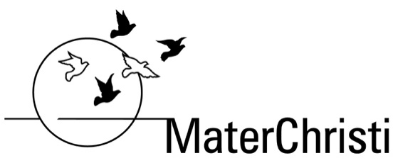

ASSESSMENT TASK
Task Name: Ancient China Inventions Task
Subject: Year 7 Humanities
Domain:
Year Level:
Statement of Inquiry: Events and ideas from past societies have significance in the modern world
Global Context:
ATL Skills Focus:
Due Date: Your Teacher will give you the due date.
Task
You have been asked by the World History Association to inform a selection panel about the impact of an Ancient Chinese invention.
You will be allocated one of the following inventions:
Paper, printing, decimal system, wheelbarrow, seismograph, matches, gunpowder, parachute, kung fu/wushu, cast iron, ink, helicopter rotor and propeller, horse collar, kite, rocket, compass, umbrella, printed book, abacus, cannon, acupuncture, spinning wheel, iron plowshare, silk
You are to write a persuasive letter
Members of the association will be asked to vote after the selection panel identifies three finalists. The letter with the most votes will receive a prize from the World History Association.
Your letter should be 350-400 words in length and should contain the following information:
a. Describe when the invention was first discovered/created.
b. Identify the Emperor who was in power at the time of discovery/creation.
c. Explain how it came to be made and how it worked.
d. Describe the problem the invention aimed to solve.
e. Explain the effect your invention had/has on the lives of ordinary people.
f. Describe how the invention is used today. Has the invention changed in appearance or use since its invention? Explain your answer.
Throughout your persuasive letter you should consistently justify the significance of the invention you have been allocated.
Describe: give a detailed account or picture of a situation, event, pattern or process
Identify: Provide an answer from a number of possibilities. Recognize and state briefly a distinguishing fact or feature.
Explain: Give a detailed account including reasons or causes
Justify: Give valid reasons or evidence to support an answer or conclusion
Steps to get started:
1.Conduct research and complete the lotus chart provided. We will begin this in class but you will also need to work on this as a homework exercise.
2.Once you have completed your research we will develop a criteria in order to evaluate the significance of your allocated invention. We will complete this step as a class.
3.Triad discussions in class justifying the significance of your allocated invention.
4.Begin writing draft.
5. Remember to keep a record of the resources you use throughout the task. A correclty referenced bibliography (Harvard style) should be submitted alongside your persuasive letter.

Academic Honesty

Students are reminded that all work submitted must be their own and each use of the words, work or ideas of another person, whether written, oral or visual, (hard copy and/or electronic materials) must be acknowledged in the body of their work and the bibliography.

Please refer to the Rubric for this assessment task for information regarding assessment criteria and task specific clarification.

