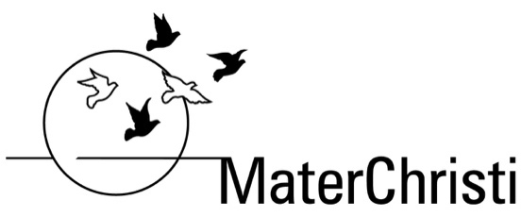

ASSESSMENT TASK
Task Name: Personal Timeline
Subject: Humanities
Domain:
Year Level:
Statement of Inquiry: Events and ideas from past societies have significance in the modern world
Global Context:
ATL Skills Focus:
Due Date:
Task
Task:
To construct and annotate a timeline of significant events that span across your lifetime.
Describe each event by including visual and researched evidence.
(A) Personal section: for the top half of the timeline.
1. Choose four significant events that happened in your life.
Include a picture and a detailed description: your description needs to include the “Who, What, Where, When, How and Why” that explains the significance of your chosen event(s). The description must include the importance of the event to your life.
2. Your time line ends in 2021. It might be helpful to bracket off (or colour code- with a legend) different phases of your life, i.e. pre-school, primary and secondary school.
(B) National and International section: for the bottom half of the timeline:
3. In the bottom half of the time line you are to include:
➢ Two global events (Impacts multiple countries)
➢ Two national events (impacts most of Australia)
Include a picture and a detailed description (your description needs to include the “Who, What, Where, When, How and Why” that explains the significance of your chosen event(s) and why it is important.
(C) Bibliography:
4. It is important to include a bibliography, which references the sources you have used accurately. Use the first website that comes up when you Google: “Citethisforme”.
o The bibliography needs to be on the back of your timeline poster. You will need to make sure that you use at least four different sources for your information.
Some important points
Keep your timeline clear and include visuals…photos.
Do not crowd the timeline; instead use the whole poster paper to display your timeline.
Checklist
o Straight line (used a ruler)
o Equal time intervals (measured using a ruler)
o Title (one for personal events)
o Title (one for national and international events)
o Underlined / bordered title with a ruler
o Annotated events
o Images included for each event

Academic Honesty

Students are reminded that all work submitted must be their own and each use of the words, work or ideas of another person, whether written, oral or visual, (hard copy and/or electronic materials) must be acknowledged in the body of their work and the bibliography.

Please refer to the Rubric for this assessment task for information regarding assessment criteria and task specific clarification.

